Abstracts title

Ivan I. Ivanov,
Doctorate student,
Moscow State University of Psychology & Education,
Moscow, Russia
ORCID: https://orcid.org/0000-0000-0000-0000,
e-mail: ivanov@yandex.ru
Petrov P. Pavel.,
PhD in Psychology, senior researcher,
Saint Petersburg State University,
Saint Petersburg, Russia
ORCID: https://orcid.org/0000-0000-0000-0000,
e-mail: petrov@mail.ru

Keywords: keyword 1, keyword 2, keyword 3.
Abstracts should contain clearly formulated scientific novelty, research problem, the approach used to solve the research problem (methodology, methods) and the main results of the study.
Table
Caption for the table
 | M (SD) | 1 | 2 | 3 | 4 | 5 | 6 | 7 | 8 | 9
Criterion No. 1
Criterion No. 2
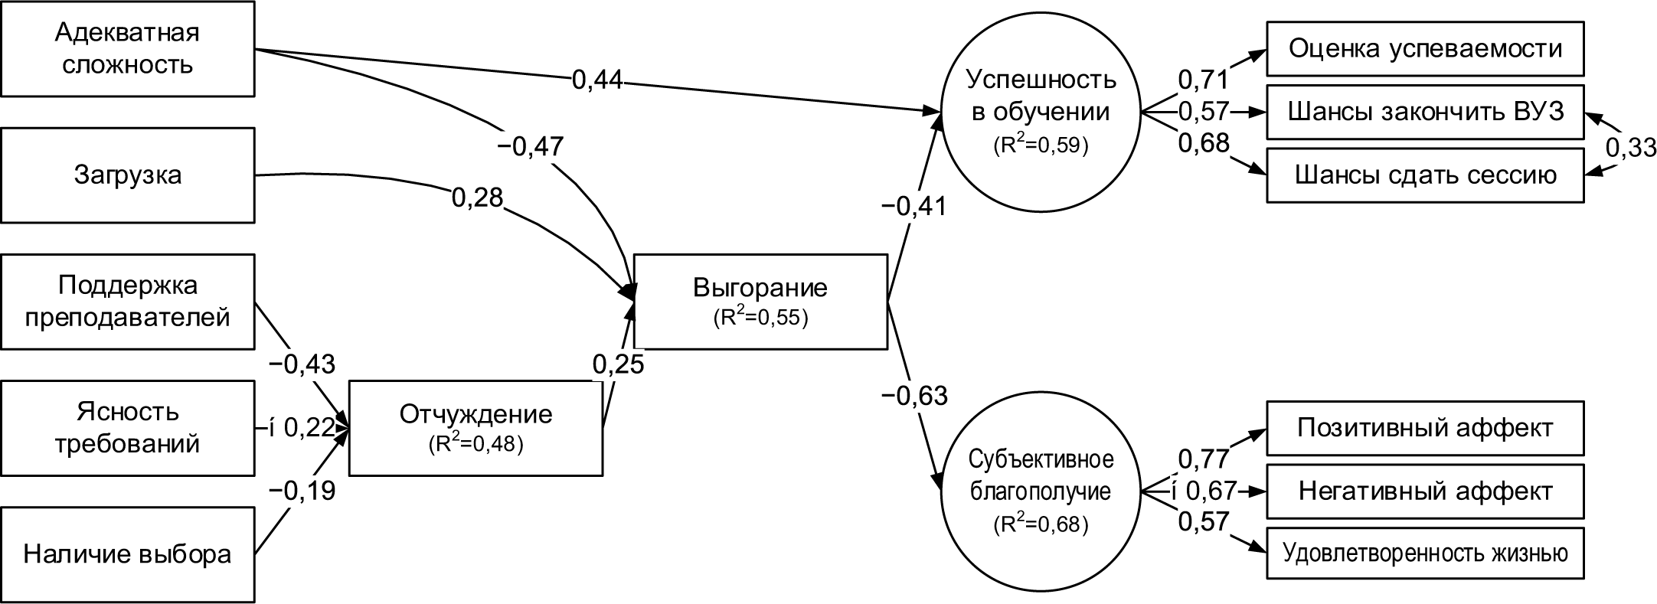
Fig. 1. Caption for the figure.

References
1. Dubrovina I.V. Idei L.S. Vygotskogo o soderzhanii detskoj prakticheskoj psihologii [Online resource] // Psihologo-pedagogicheskie issledovaniya. 2018. № 3. URL: http:// psyedu.ru/journal/2013/3/3432.phtml (date of visit: 18.11.2018).
2. Zabrodin Yu. M., Rubcov V.V. Koncepciya i organizacionno-strukturnye modeli psihologicheskoj sluzhby obrazovaniya [Online resource] // Psihologo-pedagogicheskie issledovaniya. 2016. Tom 8. № 3. S. 1–15. DOI:10.17759/psyedu.201608030
3. Blair C. How similar are fluid cognition and general intelligence? A developmental neuroscience perspective on fluid cognition as an aspect of human cognitive ability // Behavioral Brain Science. 2006. Vol. 29. № 2. P. 109–125. DOI:10.1017/S01405 25X06009034

Funding (optional). The research was supported by the Russian Foundation for Basic Research (RFBR) within the framework of the scientific project No. 00-00-00000.

Acknowledgements (optional). The authors thank scientific leader of the project P.P. Petrov for the help in collecting data for the study.

ORCID is specified if applicable

